 |  |  |  | DISTRIBUTION
PROJECT | UNR-Mathewson | REPORT # | 004
LOCATION | Reno, NV | TRIP DATE | 02/29/2024
PROJECT # | A9941.01 | ENGINEER/Observer | Anand Mourougassamy
CLIENT | LMN Architects | TODAY’S DATE | 3/1/2024
CONTRACTOR | Clark Construction | PAGE | 1 OF 7

OBSERVATIONS/ACTIVITY
Time: 10:00 am
Weather: Windy 45 °F
Present: Clark Construction – Brian Peart, Chase Johnson
Magnusson Klemencic Associates – Anand Mourougassamy, Hannah Bonotto

Clark and MKA walked the UNR Mathewson site to observe the steel construction between grids 1 to 12 in progress and the completed partial mat at core 3 as shown in Figures 1- 3.

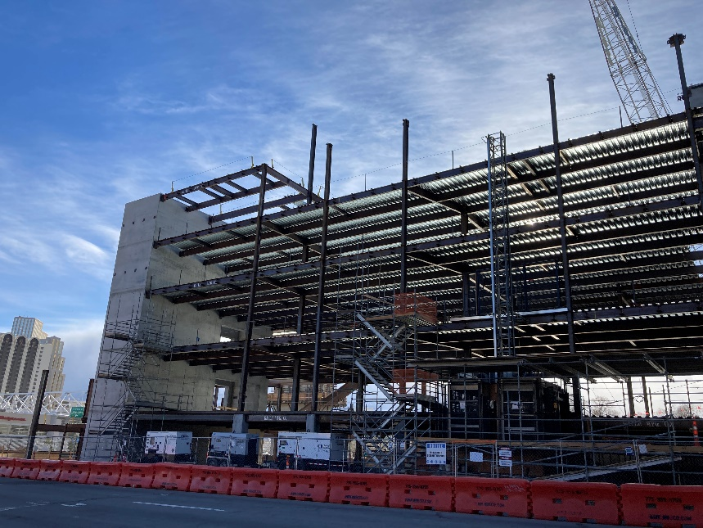
Figure 1. Overall view of steel at level 1-4 looking south from grid 4
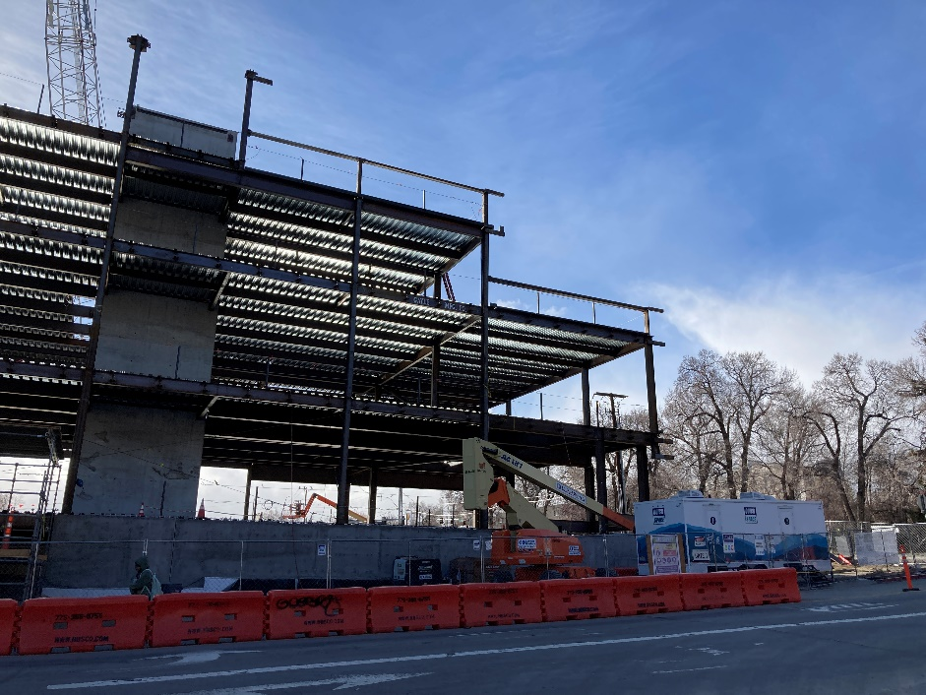
Figure 2. View looking north near grid 4

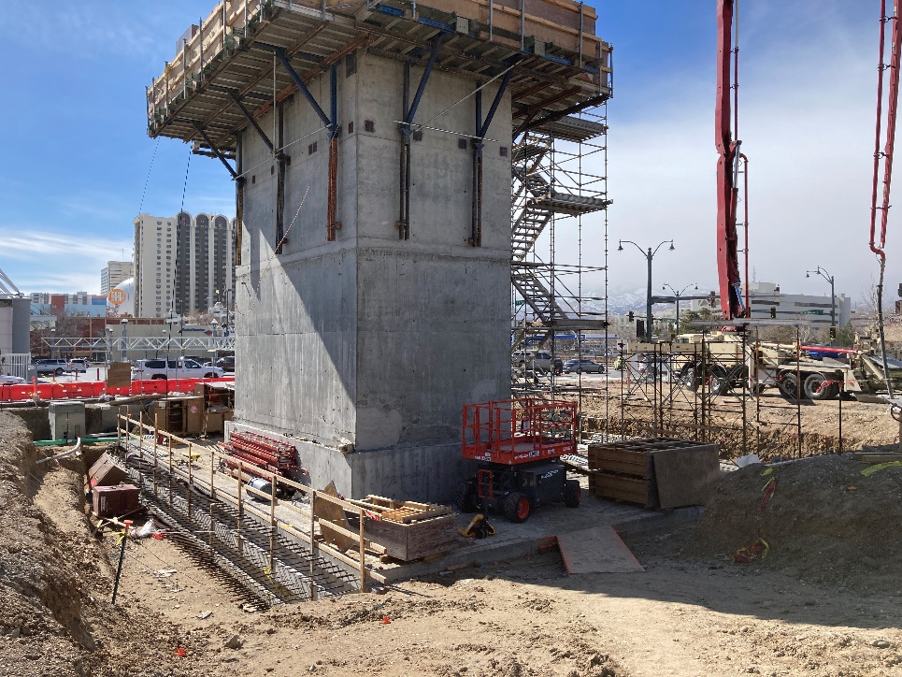
Figure 3. View looking east at completed partial mat at core 3

- MKA observed the completed steel at levels 02 and 03 between grids 1-12. Steel beams and columns were in place and welded connections at embed plates in progress. Steel deck was in place and attachment to steel in progress. The in-place steel appeared to be generally in conformance with the contract documents.  Action: None | 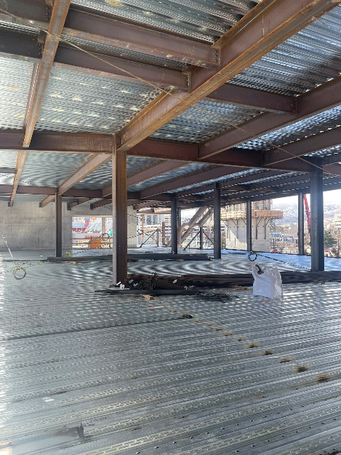  Figure 4. View of steel looking south from grid 5
- At multiple C28 drag connections around core 1 at level 02 and 03, embed plates appeared to be out of tolerance vertically per 01 71 00. Consequently, flange plate locations are not in conformance with 19/S438.  Action: Contractor to submit RFI with embed plate survey data for all out of tolerance embeds and request field fix modifications. | 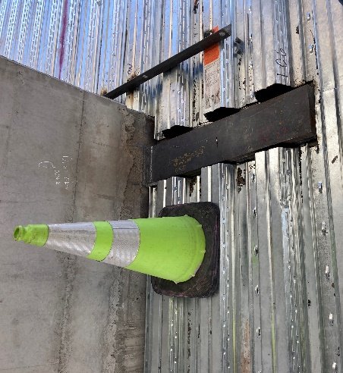  Figure 5. View of C28 connection at Grid 4/B
- At deck support angles along core walls at grid 4, MKA observed the washer plates at drilled in concrete anchors per the hoist drawings to be not in place and a few anchors to be missing. Weld from deck to support angles was also not in place.  Action: Contractor to confirm the installation of the washer plates at drilled in concrete anchors prior to hoist usage per hoist drawings.  Contractor to confirm the installation of anchors and welds at specified spacing per structural drawings | 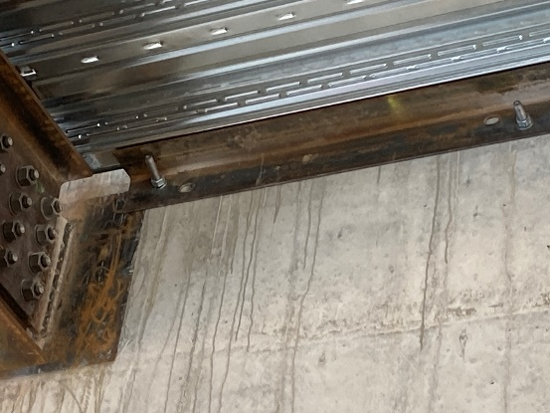  Figure 6. View looking underside of deck at the support angle along Grid 4
- MKA observed the deck support angles along core walls at grid 10 to be not in place.  Action: Contractor to confirm the installation of deck support angles per structural drawings or alternate shown in note 3 of detail 16/S441 will be followed during concrete placement. | 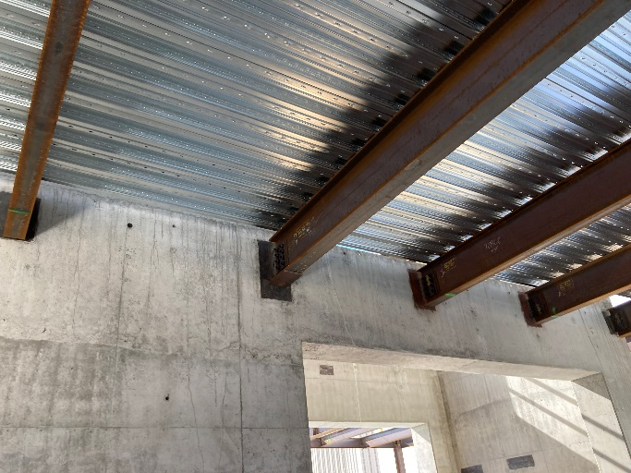  Figure 7. View looking at underside of the deck along Grid 10
- MKA observed the completed partial mat at core 3. The in-place reinforcement for coupling appeared to be generally in conformance with the contract documents.  Action: None. | 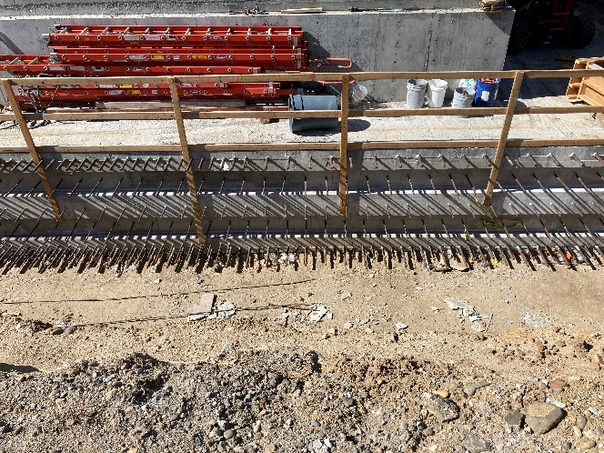  Figure 8. Reinforcement at mat near Grid H at core 3

I:\UNR_Mathewson\Construction Admin\FieldReports\20240301_UNR_MKA Construction Observation Report_004.docx

